Jacob Dineen

IST 722 Data Warehouse

10/12/17

NetID: Jdineen

Part 3: On Your Own

|  |  |  |  |  |
| --- | --- | --- | --- | --- |
| **Table** | **Type** | **Row Count** | **Business Key** | **One Row Is** |
| Employees | Master Data | 9 | None (Pk Used) | An Employee |
| EmployeeTerritories | Business Process | 49 | None (Pk Used) | An employee assigned to a territory |
| Customers | Master Data | 91 | Yes/No – Abbreviation of Company name used as primary key | A Customer |
| Suppliers | Master Data | 29 | Company Name | A Supplier |
| Products | Master Data | 77 | ProductName | A Product |
| Shipments (of Orders) | Business Process | 830 | None (Pk Used- OrderID) | Order Shipment Details |
| Details (of an order) | Master Data | 2155 | None (Pk Used) | Details of an order |

I think that EmployeeTerritories and Shipments are the only business processes seen above. The other tables exist to store information about a business entity (Employees, Customer, Suppliers, Product). Order details, I also assumed, was master data which the Orders table referenced.

We could potentially use Company Name as a business key on Customers, but we run the risk of having multiple companies with the same name. We could also think about using Company name on the Suppliers Table as a business key, but again, we risk duplication. ProductName could be used as a business key, as it appears to be unique.

Part 2:

**Write SQL queries to answer the following questions that might be associated with functional business requirements in a data warehouse. For each of the following provide a screenshot of the SQL query and its output, making sure your name or NetID appears in the screenshot.**

**1. List the customer contact names and titles sorted by company name.**

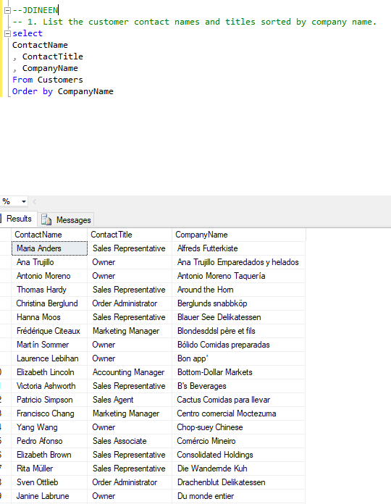

**2. Factoring in discounts, what is total amount of product sold?**

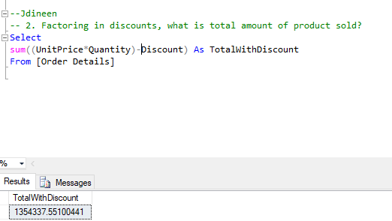

**3. Provide a list of product category names with counts of products in each category.**

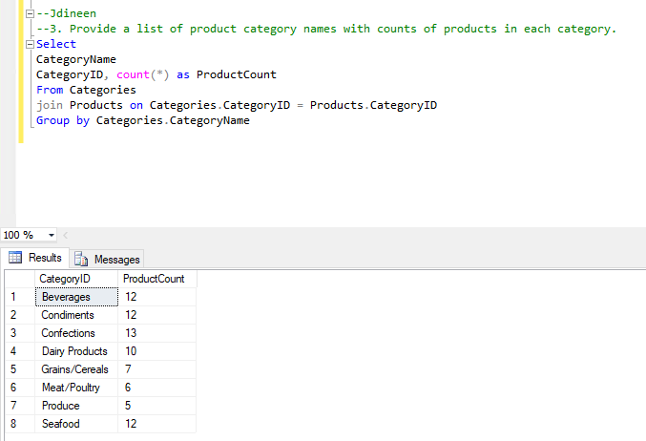

**4. Select a specific customer, and display that customer’s orders with total amount of product sold for each order.**

Part 1: I could not group by both company name and company id, so I will need to remove companyname and simply show the orders aggregated.

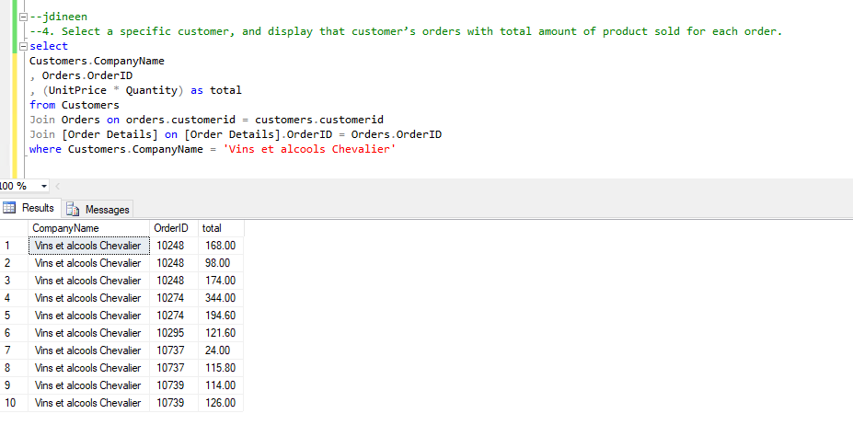

Part 2: Grouped Order:

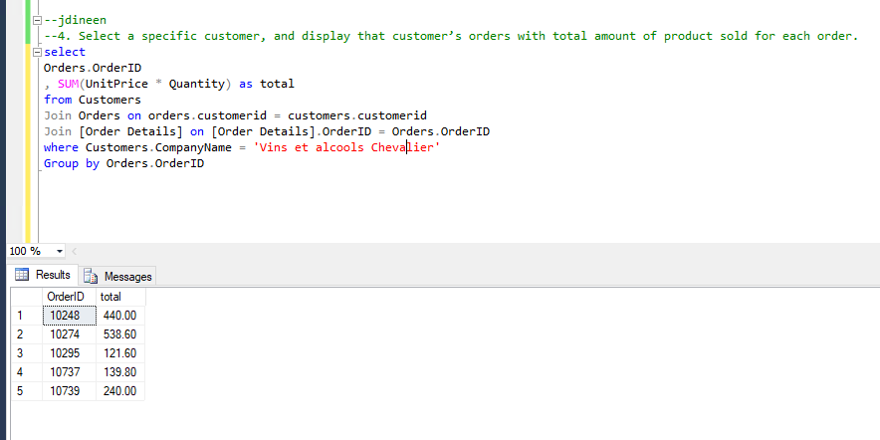

**5. Select a specific employee and each order, how it was shipped (shipvia), the company who shipped it, and the total number of days elapsed from order date to shipped date.**

Select

Employees.LastName

,Employees.FirstNamesss

,Orders.OrderID

,Orders.Shipvia

, Shippers.CompanyName

, DATEDIFF(d, Orders.OrderDate, Orders.ShippedDate) as DaysElapsed

from Employees

Join Orders on Orders.EmployeeID = Employees.EmployeeID

Join Shippers on Shippers.ShipperID = Orders.ShipVia

where Employees.EmployeeID = 1

